Sponsored by: 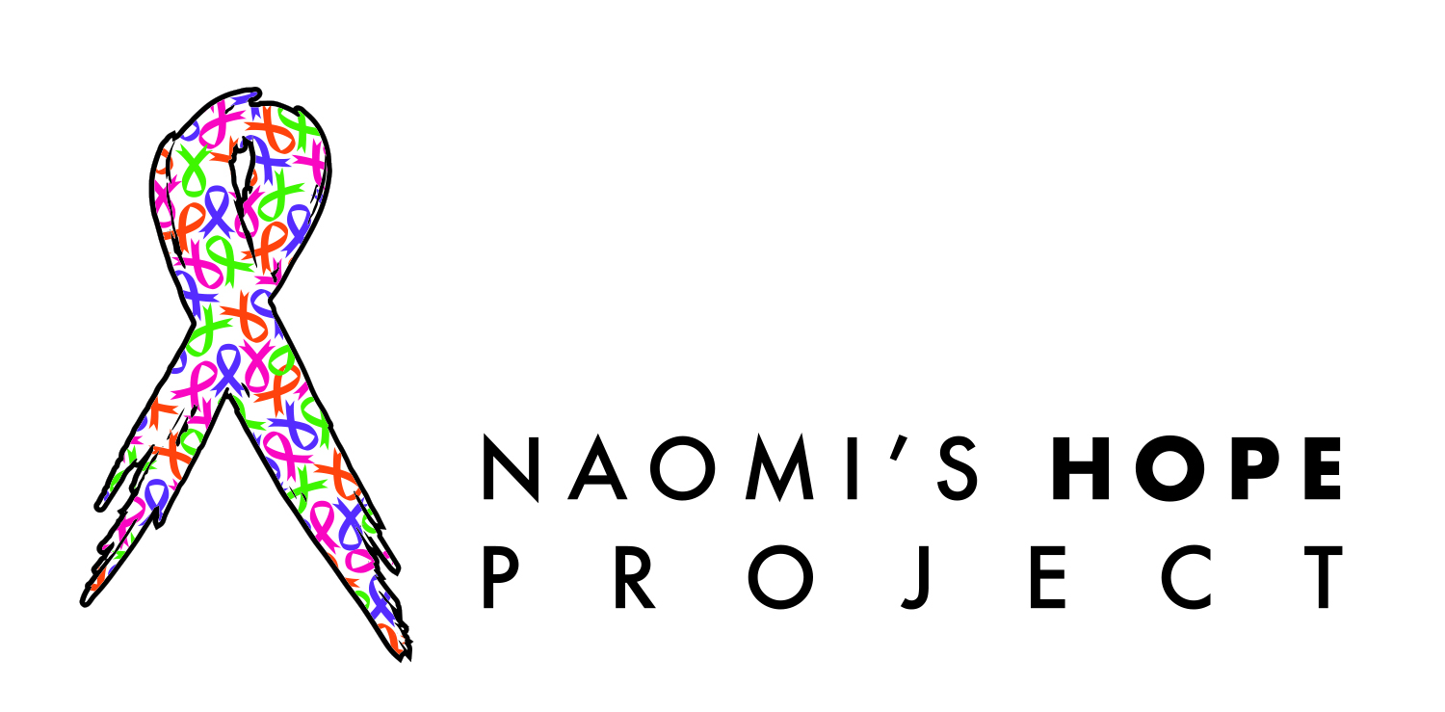
Because No One Fights Alone….

Horseshoe Tournament
Offered by Naomi’s Hope Project
709 NuVue St., Delta, CO 81416
Phone: 970-209-8978
www.naomishopeproject.org
Horseshoe Tournament
S[
Saturday, July 27
Cleland Park
Registration at 9:30AM
Tournament at 10:30AM

Payment Information

Total being charged:
Check #
CC# _______
Exp:
CVC:____________
Or online @ NAOMISHOPEPROJECT.ORG
(USE THE DONATION BUTTON)

Legal Waiver & Signature
I hereby certify that I have carefully read, understand and agree to the Registration and will be legally bound by this release (waiver). I certify that I have entered this race of my own free will. I am in physical condition that allows me to enter this event. In consideration of the acceptance of my entry, I do, for myself, my heirs, administrators and executor waive and release forever, any and all rights to claims with suits for damages I might accrue against the City of Delta, Delta Area Chamber of Commerce, its sponsors, volunteers and/or beneficiaries, for any and all injuries suffered by me while traveling to, from and while participating in the race event. Further, I certify that I am covered by my own medical insurance or, failing that, accept full responsibility for any and all expenses I may incur. My photograph, likeness, or video may be used for any legal purpose by race organizers. I have read this waiver and agree to its terms.

Sign:
Date:
(Parent/legal guardian must sign if participant is under the age of 18)

Please remit your application and payment to:
DACC, 301 Main St, Delta, CO 81416
Or Email to director@deltacolorado.org

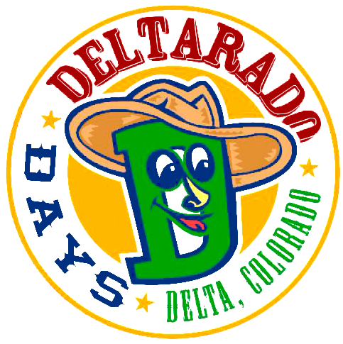

Don’t be late!
The tournament starts RIGHT at 10:30 AM so don’t be late!

There will be cash prizes and trophies for the top 3 teams!

Be safe and courteous of the people around you. And don’t forget to thank Naomi’s Hope Project for sponsoring and running the show!

If you didn’t pre-register NO PROBLEM be at Cleland Park at 9:30 am, and we’ll get you in!

- Just a heads up, we may not have a
t-shirt your size if you are registering the day of.

* There will be no refunds*

Follow the Rules
- Underage drinking will constitute a forfeiture of game and those involved. Law enforcement will be notified
- Drink responsibly
- All final rulings will be made by a Naomi’s Hope Project Representative

Contestant Information

Name:

Teammate’s Name:

Address:

Phone:

Email:

Emergency Contact:

T-Shirt Info

Gender: Male Female

Size (circle one): XXL XL L M S

YL YM YS

Cost per Person

$25.00

Price includes a T-Shirt; same day registration
does NOT guarantee size

Please remit your application and payment to:
Naomi’s Hope Project
709 NuVue St - Delta
Or Email to naomishopeproject.org
Fees
Before July 1st with guaranteed t-shirt - $20
After July 1st with NO guaranteed t-shirt - $20

On Race Day - $25
*no guarantee of t-shirt or goodie bag
*cash or check only
Fees
Before July 1st with guaranteed t-shirt - $20
After July 1st with NO guaranteed t-shirt - $20

On Race Day - $25
*no guarantee of t-shirt or goodie bag
*cash or check only
Fees
Before July 1st with guaranteed t-shirt - $20
After July 1st with NO guaranteed t-shirt - $20

On Race Day - $25
*no guarantee of t-shirt or goodie bag
*cash or check only

